**Lab 01 : Package and Dependencies**

**Step 1 : Goto API & Services**

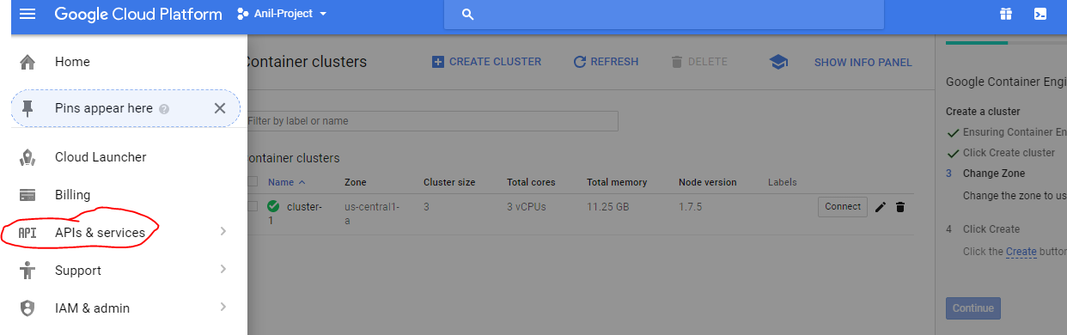

**Step 2 : Enable Google cloud resource Manager API**

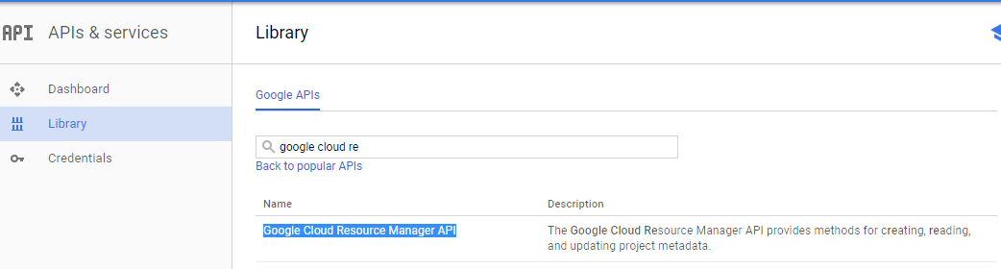

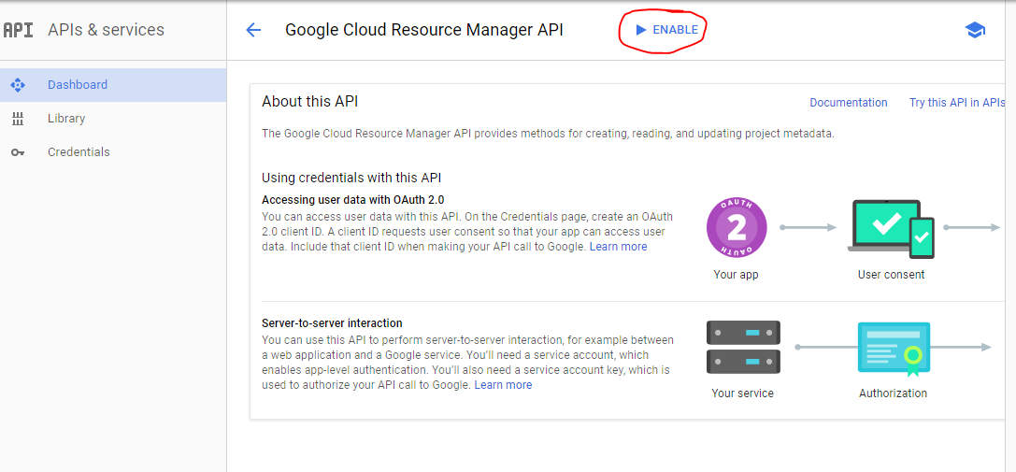

**Step 3 : Got IAM tab > Click create a service account**

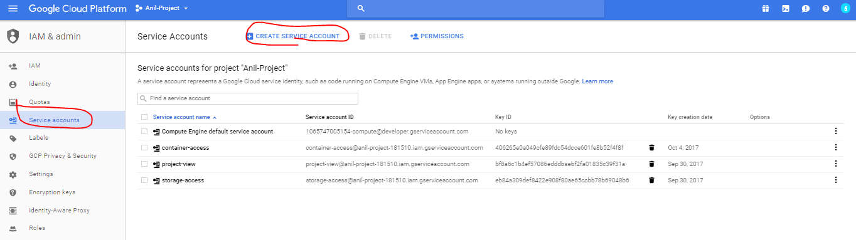

**Step 4 : Provide a name and add permission “ Project owner”**

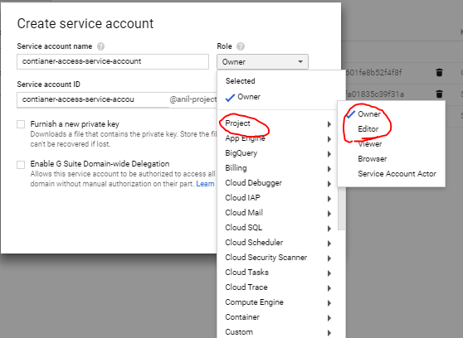

**Step 5 : Provide a name and add permission “ Container Engine Admin”**

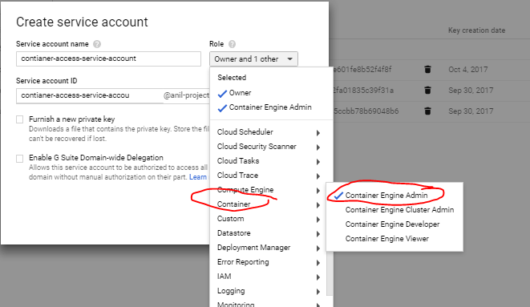

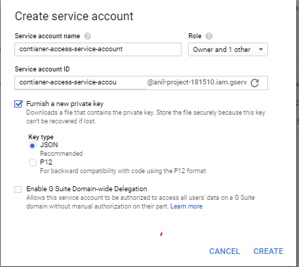

**Step 6 : Launch a instance with centos7 image and use container access service account**

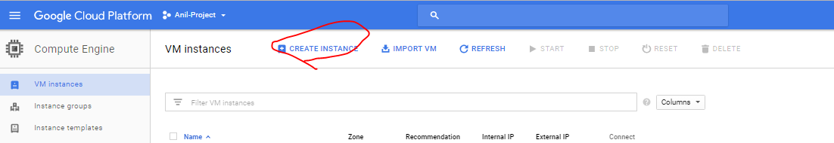

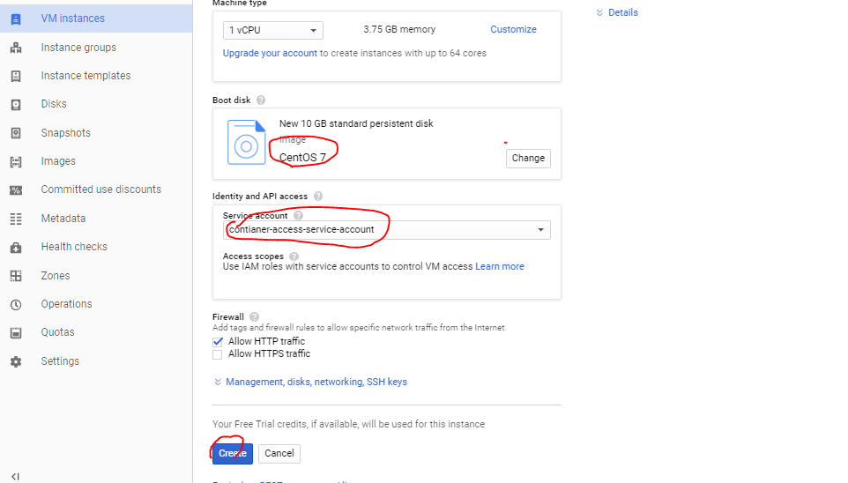

**Step 7 : SSH to your vm**

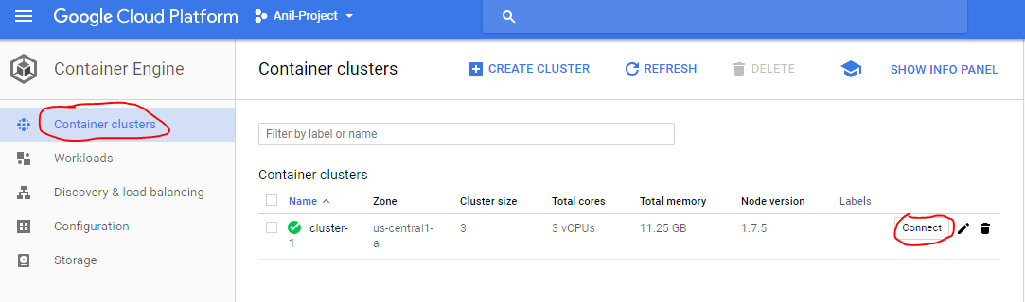

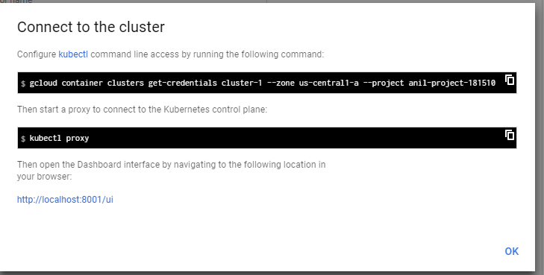

**Step 1 : on your vm**

# gcloud init

**Step 2 : get credntials**

gcloud container clusters get-credentials cluster-1 --zone us-central1-a --project anil-project-181510

kubectl proxy

kubectl get nodes